TOURNAMENT INFORMATION-THE CLASSIC
MAY 16-17, 2026
LAKE GUNTERSVILLE-GOOSE POND COLONY
417 ED HEMBREE DR. SCOTTSBORO, AL 35769

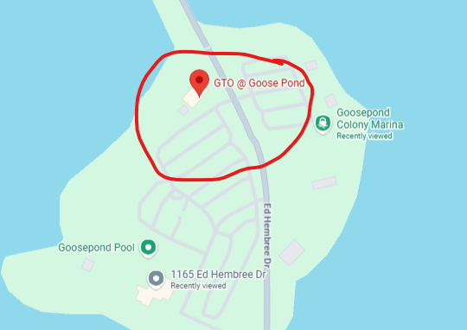

TOURNAMENT AND SAFETY MEETING WILL RUN ON EASTERN TIME
CHECK IN FOR THE TOURNAMENT WILL BEGIN BY 4:45AM EASTERN TIME, LOOK FOR THE STAGE TRAILER! SAFETY MEETING WILL START BY 5:30AM EASTERN TIME WITH BLASTOFF AT SAFELIGHT (AROUND 6:30AM EASTERN TIME)!
WEIGH IN: JUNIORS MUST HAVE CHIPS ON THE BOARD BY 2PM EASTERN TIME, SENIORS MUST HAVE CHIPS ON THE BOARD BY 3PM EASTERN TIME

LAUNCH NUMBERS WILL BE DRAWN FOR DAY 1 AT CHECK IN BEFORE THE SAFETY MEETING, IF YOU MISS THE START OF THE SAFETY MEETING YOU WILL BE AT THE BACK OF THE LAUNCH FOR YOUR PROSPECTIVE DIVISION!!

