TOURNAMENT INFORMATION
NOVEMBER 8, 2025
LAKE ALLATOONA-GATEWOOD PARK
224 BARTOW BEACH RD
CARTERSVILLE, GA
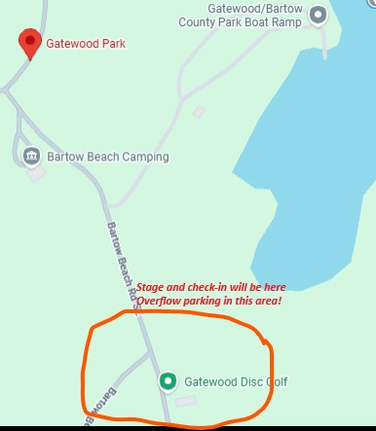

CHECK IN FOR THE TOURNAMENT WILL BEGIN BY 4:45AM IN THE PARK BY THE STAGE TRAILER. SAFETY MEETING WILL START BY 5:30AM WITH BLASTOFF AT SAFELIGHT (AROUND 6:30ISH AM) ALL ANGLERS MUST CHECK IN TO BE ABLE TO WEIGH IN!!
WEIGH IN: JUNIORS MUST HAVE CHIPS ON THE BOARD BY 2PM, SENIORS MUST HAVE CHIPS ON THE BOARD BY 3PM.

PARKING WILL BE PREMIUM IN THE BOAT RAMP LOT
IF YOU DO NOT HAVE A BOAT AND TRAILER PLEASE PARK IN THE PARK AND NOT AT THE BOAT RAMP
OVERFLOW PARKING FOR BOAT TRAILERS IS ALSO IN THE PARK AREA.
DO NOT PARK ON THE GRASS FIELD IN THE PARK
DO NOT PARK ON THE GRASS FIELD IN THE PARK
DO NOT PARK ON THE GRASS FIELD IN THE PARK

