TOURNAMENT INFORMATION
APRIL 18, 2026
MARY ALICE PARK
MARY ALICE PARK RD
CUMMING, GA 30041
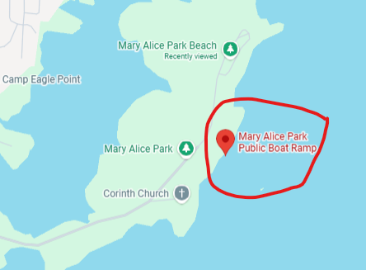

CHECK IN FOR THE TOURNAMENT WILL BEGIN BY 4:30AM BY THE STAGE TRAILER. SAFETY MEETING WILL START BY 5:30AMish WITH BLASTOFF AT SAFELIGHT (AROUND 7AMish) ALL ANGLERS MUST CHECK IN TO BE ABLE TO WEIGH IN!!
WEIGH IN: JUNIORS MUST HAVE CHIPS ON THE BOARD BY 2PM, SENIORS MUST HAVE CHIPS ON THE BOARD BY 3PM.

IF YOU DO NOT HAVE A BOAT AND TRAILER PLEASE DO NOT PARK IN TRAILER SPOTS

WE WILL GO OVER THE CLASSIC INFORMATION AT THE SAFETY MEETING!

